

*EMOTIV Headset Data Acquisition Manual*

Researchers:

Griselda Cortés Barrera

Claudia Teresa González Alfaro

Jhacer Kharen Ruiz Garduño

Jorge Abraham Jiménez Alfaro

Index

Headset Components 3

EMOTIV Launcher Installation 4

Headset Connection with EMOTIV 8

1. Device Fitting 10
2. Contact Quality 12
3. EEG Quality 13

Data Collection with Cortex App and C# 13

Example: 19

**Index of figures**

*Figure 1Physical Components of the Headset* 3

*Figure 3 Access Screen* 4

*Figure 2 Official EMOTIV Headset Website* 4

*Figure 4 Platforms for Software Download* 5

*Figure 5 Complete Emotiv Software Download* 5

*Figure 6 Administrator Mode Execution* 6

*Figure 7 Start Page for Configuration* 6

*Figure 8Application Access Path* 6

Figure 9 Installation Folder 7

Figure 10 Installation Components 7

Figure 11 Installation of the EMOTIV Application 7

Figure 12 EMOTIV Application 8

Figure 13 Login Screen 8

Figure 14 Username and Password 8

Figure 15 Login Window 9

*Figure 16 Device Detection* 9

Figure 17 Main Menu 10

Figure 18 Headset Placement Check 11

Figure 19 Good Headset Placement Check 11

Figure 20 Correct Headset Position 12

Figure 21 Sensor Adjustment 12

Figure 22 EEG Signals 13

Figure 23 Documentos de ejemplo 13

Figure 24 GitHub Repository 14

Figure 25 Cshap Folder 14

Figure 26 Visual Studio Project 15

Figure 27 CtxClient.cs 15

Figure 28 Source Code 16

Figure 29 Program Execution 16

Figure 30 My Account 16

Figure 31Cortex Application Start 17

Figure 32 Cortex Application 17

Figure 33 Application Registration 18

Figure 34 Key Generation 18

Figure 35 Config.cs 18

Figure 36 Authentication Variables 19

Figure 37 Variables for authentication 19

Figure 38 EELogger Option 19

Figure 39 BandpowerLogger 19

Figure 40 Program Execution 19

Figure 41Connection Authentication 20

Figure 42 Generated Documents 20

Figure 43 Datos iniciales 20

Figure 44 Right Side Motion Register 20

Figure 45 Standing Motion Registration 20

Figure 46 Left side motion register 20

Figure 47 Thrust Motion Log 20

# **Headset Components**

* + - 4 rubber sensors: AF3, AF4, T7, T8.
    - 1 three-pronged rubber sensor: for better hair penetration at Pz.
    - Three rubber bands***
    - Liquid bottle
    - Hex key
    - USB receiver
    - USB charging cable
    - Case
    - Headset

*Figure 1Physical Components of the Headset*

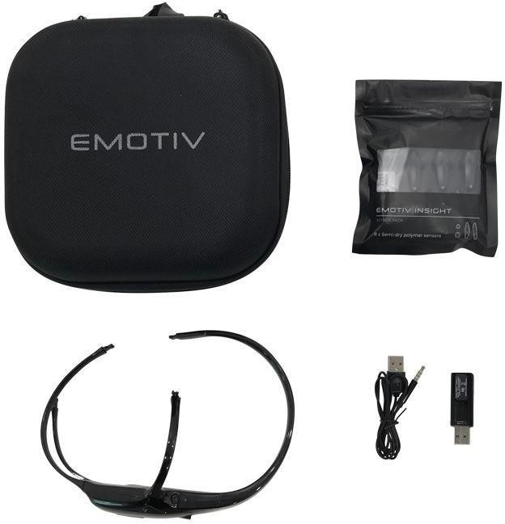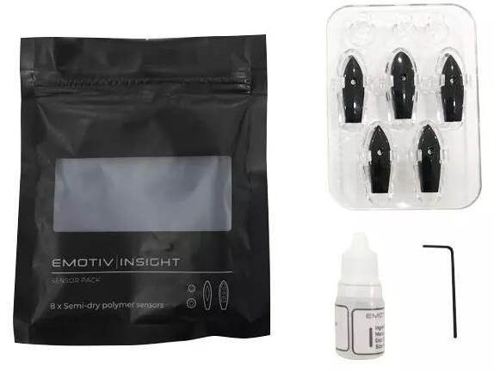

# **EMOTIV Launcher Installation**

1. Go to the website <https://www.emotiv.com/get-started/> where you can download the EMOTIV App depending on your Operating System.

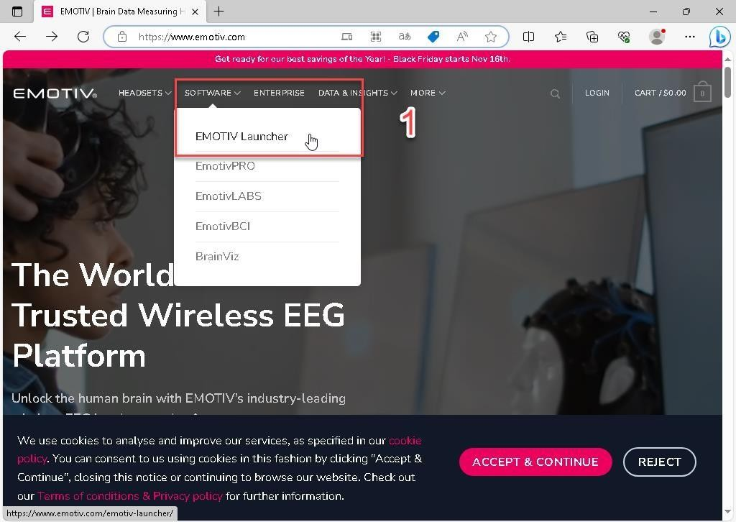

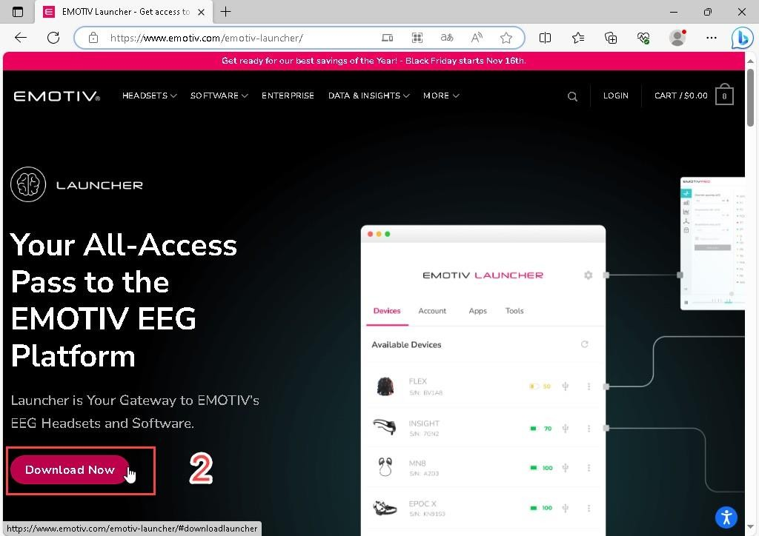

*Figure 2 Access Screen*

*Figure 3 Official EMOTIV Headset Website*

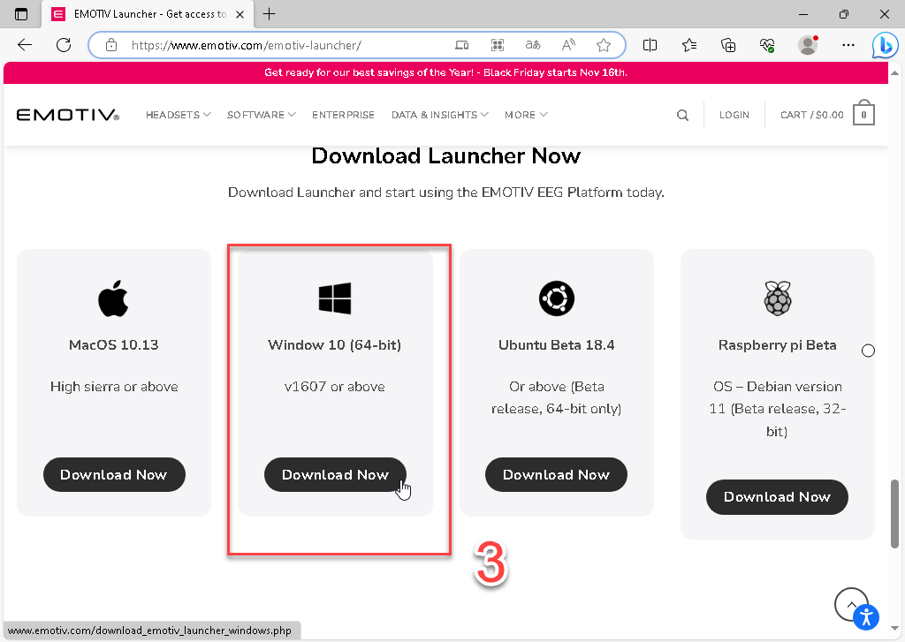

*Figure 4 Platforms for Software Download*

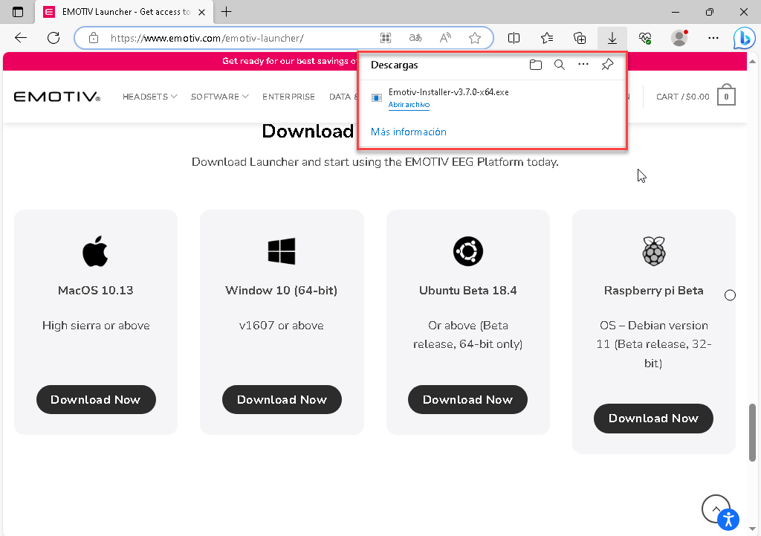

*Figure 5 Complete Emotiv Software Download*

1. Run it as an administrator. Select the location where the application will be installed.

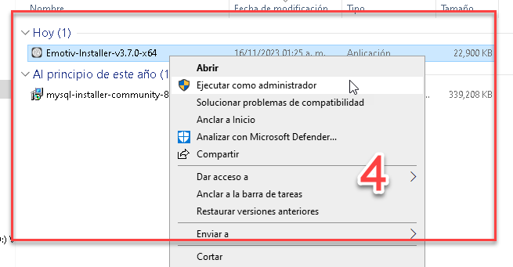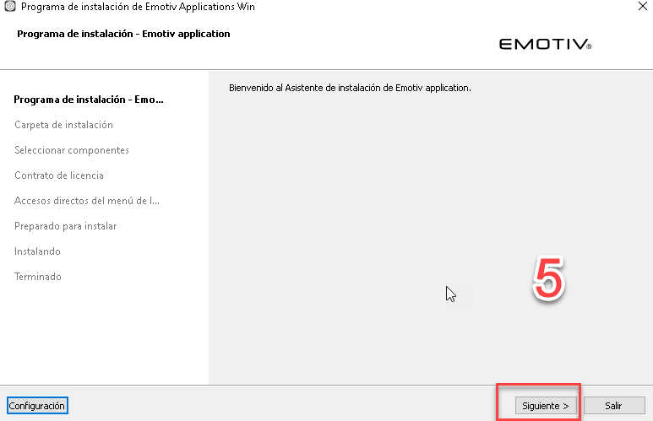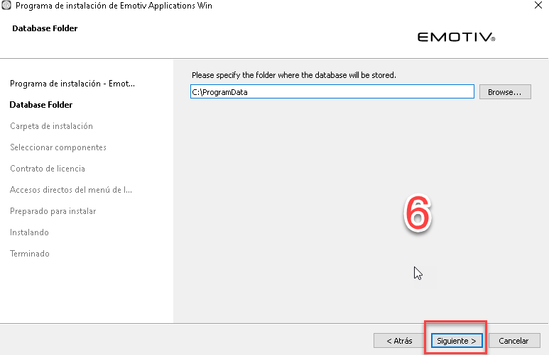

*Figure 6 Administrator Mode Execution*

*Figure 7 Start Page for Configuration*

*Figure 8Application Access Path*

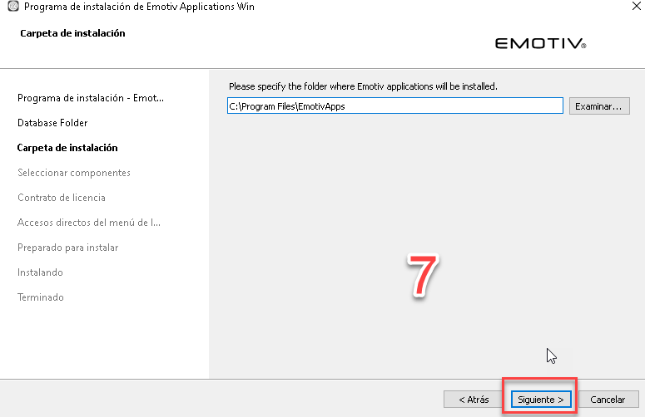

Figure 9 Installation Folder

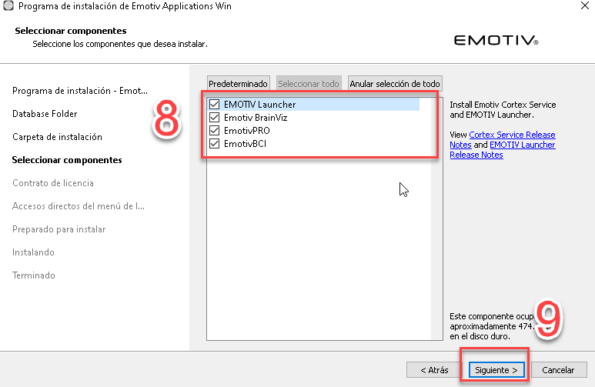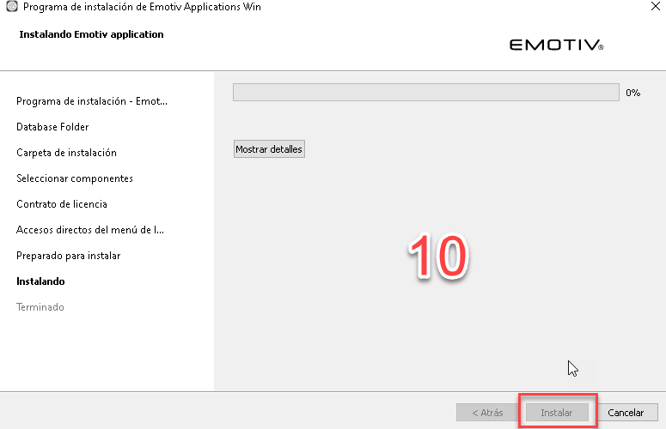

Figure 10 Installation Components

Figure 11 Installation of the EMOTIV Application

1. Finally, we obtain the application.

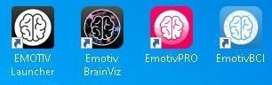

Figure 12 EMOTIV Application

# **Headset Connection with EMOTIV**

1. We will start with the following username (EmotivD) and password.

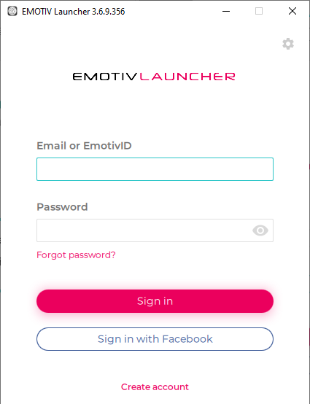

Figure 13 Login Screen

Figure 14 Username and Password

**Username:** tese

**Password:** Tese1234

1. 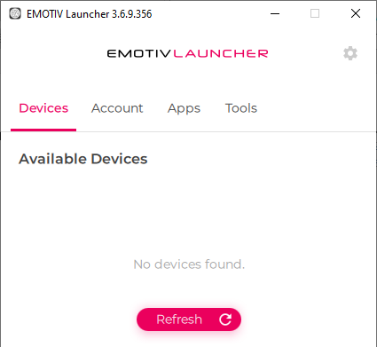When you log into the application, you will see the following window.

Figure 15 Login Window

Once the USB receiver (Bluetooth) is connected to the computer, it should be detected and displayed in the window.

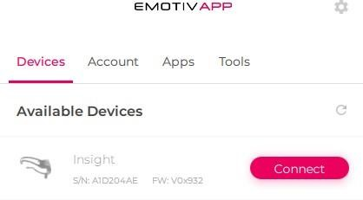

**NOTA:**

En caso de que no aparezca presionamos el botón refrescar, Si esto no funciona, vuelva a apagar y prender la diadema.

*Figure 16 Device Detection*

EMOTIV Application Menu Headset Configuration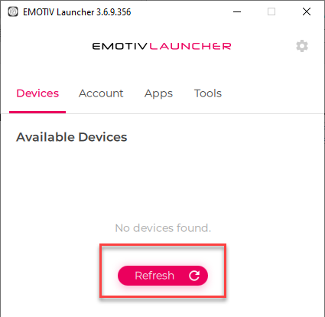

Figure 17 Main Menu

The following steps outline the configuration process:

### Device Fitting

Steps to get the headset functioning:

**Step 1:** Place the headset on your head so that the reference sensor arm makes firm contact with the skin behind your left ear.

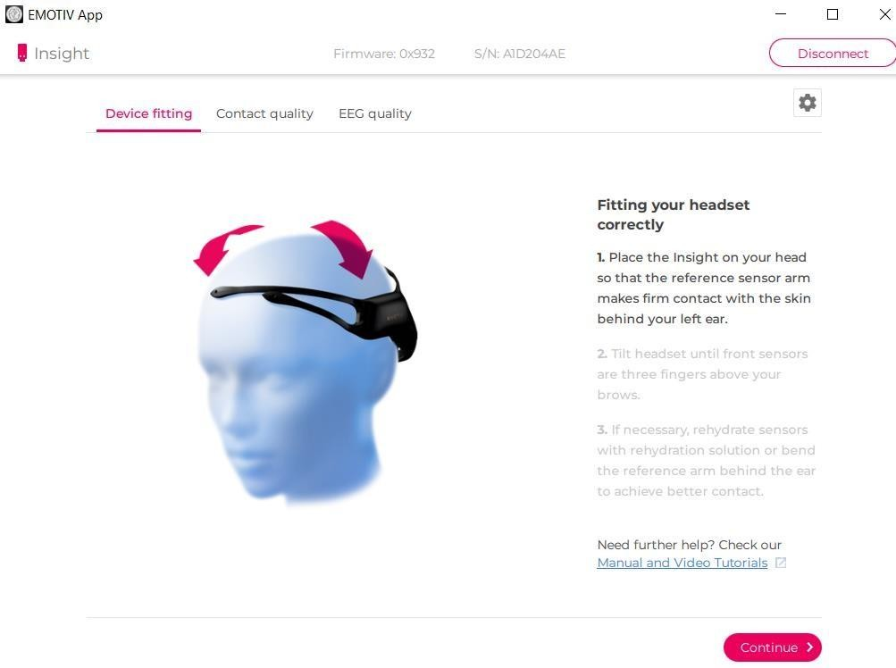

Figure 18 Headset Placement Check

**Step 2:** Tilt the headset until the front sensors are three fingers above your eyebrows.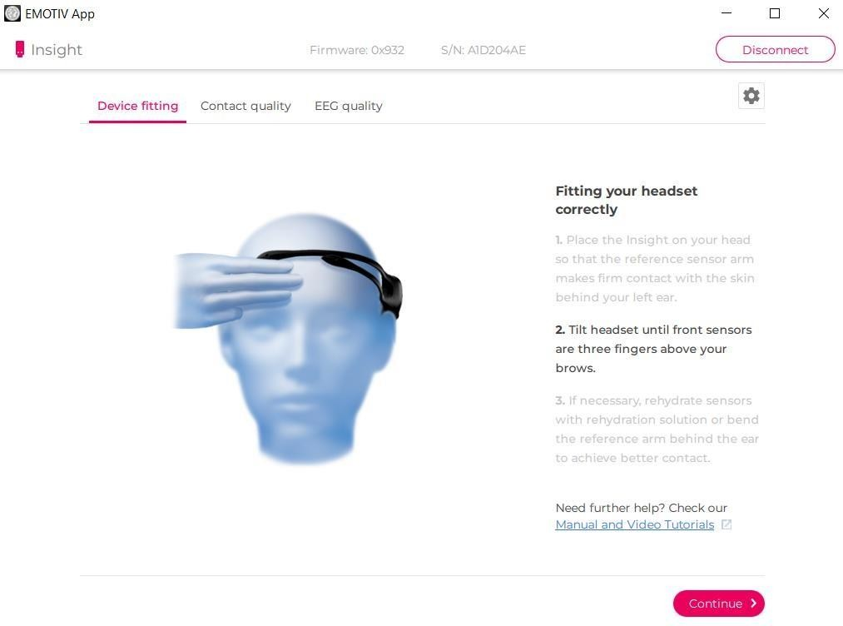

Figure 19 Good Headset Placement Check

**Step 3:** If necessary, rehydrate the sensors with rehydration solution or adjust the reference arm behind the ear for better contact.  
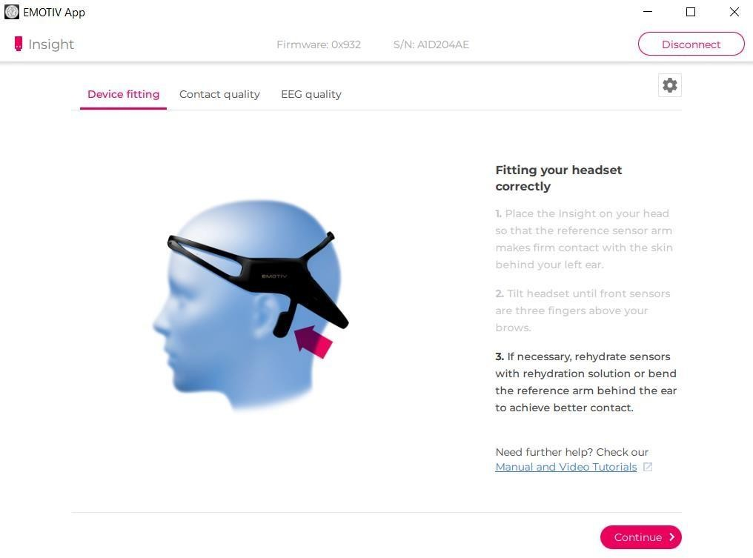

Figure 20 Correct Headset Position

### Contact Quality

**How to Ensure Good Contact Quality:**

Work each sensor underneath the hair to make contact with the scalp. If all sensors are black, first adjust the reference sensors (the two pointed cones on the arm behind the left ear) until they turn green, and then adjust the other sensors..

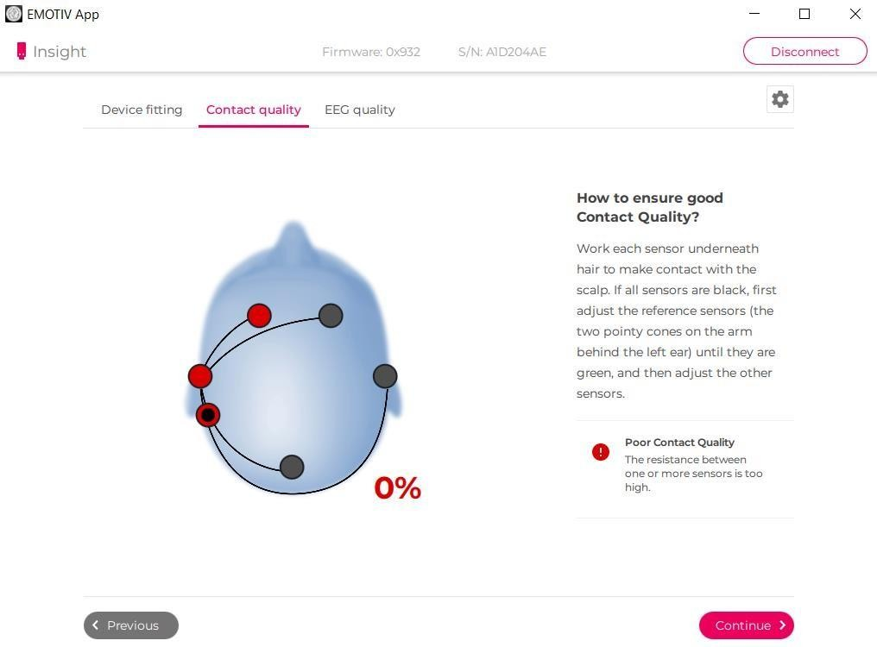

Figure 21 Sensor Adjustment

### EEG Quality

**How to Ensure Good EEG Quality:**

To ensure good quality, click on the sensors to compare the current signals with typical high-quality EEG signals.

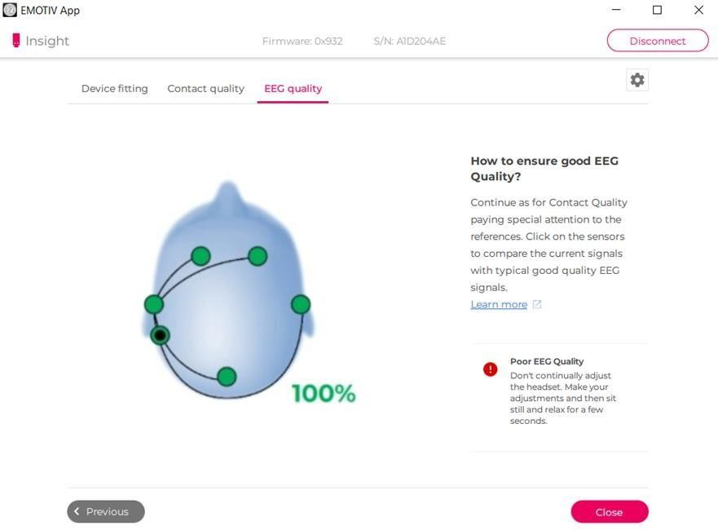

Figure 22 EEG Signals

# **Data Collection with Cortex App and C#**

As an alternative tool, we will use the C# program with Visual Studio (required).

The code is available from Emotiv, under the Developer section. The following link redirects to that section, where we will look for “Documentation & Examples”

As shown in the image, there are three icons; click on the “Examples” icon: <https://www.emotiv.com/developer/>.



Figure 23 Documentos de ejemplo

This will take you directly to the Emotiv repository on GitHub (<https://github.com/Emotiv/cortex-v2-example>), and you will see what is shown in the image.

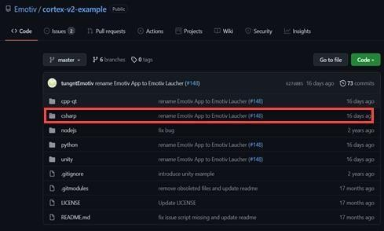

Figure 24 GitHub Repository

Look for the “Cshap” folder, as it contains the Cortex API in C#.

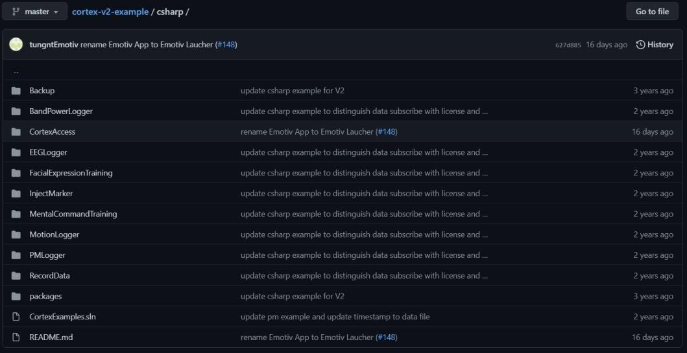 <https://github.com/Emotiv/cortex-v2-example/tree/master/csharp>

Figure 25 Cshap Folder

Se abre el proyecto con el IDE Visual Studio (2014 o superior).

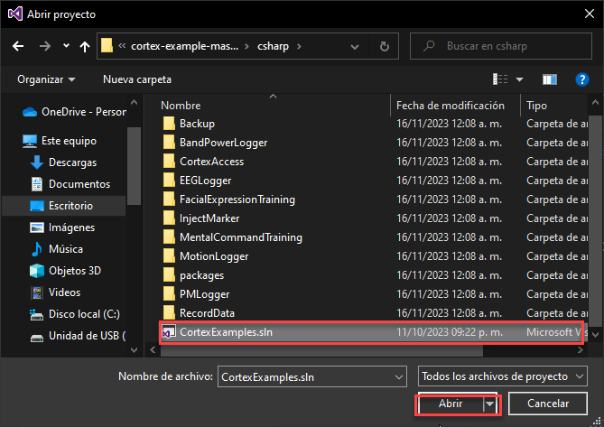

Figure 26 Visual Studio Project

Before running the program, make the following modifications: open the “CtxClient.cs” file and modify the Authorize method.

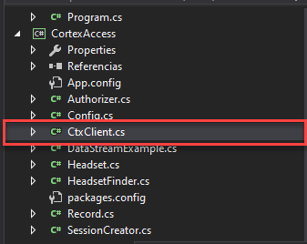

Figure 27 CtxClient.cs

Make the following changes in the source code:

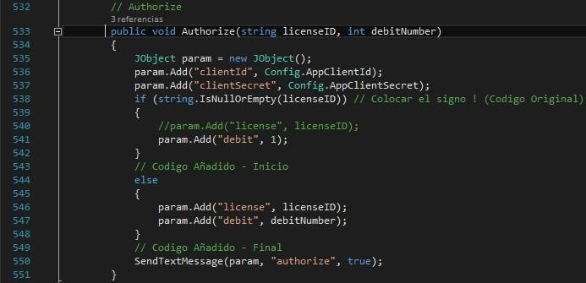

Figure 28 Source Code

When you find line 541, change the 0 to 1. This allows the Emotiv API to access the permissions. Then proceed to run the program.

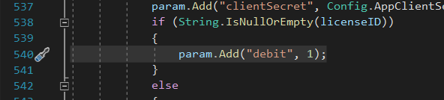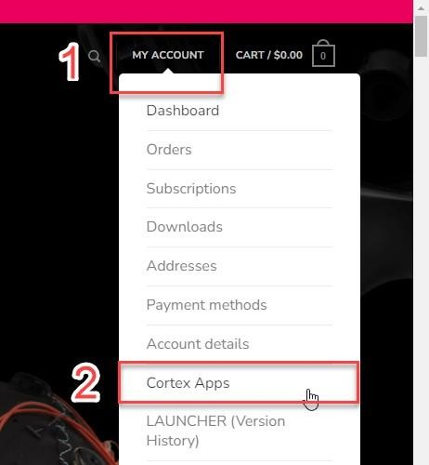

Figure 29 Program Execution

Figure 30 My Account

The next step is to generate two keys to use the program. You need to log in to the platform (<https://www.emotiv.com/get-started/>) and go to the “MY ACCOUNT” section and click on the “Cortex Apps” option

Accept the terms and conditions and click the “Continue” button.

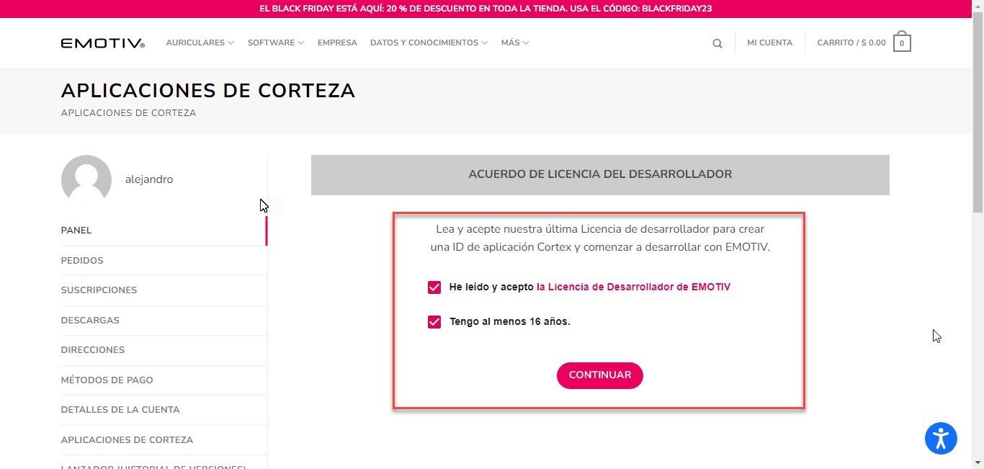

Figure 31Cortex Application Start

The following window will appear, where you will generate the two required keys.

Figure 32 Cortex Application

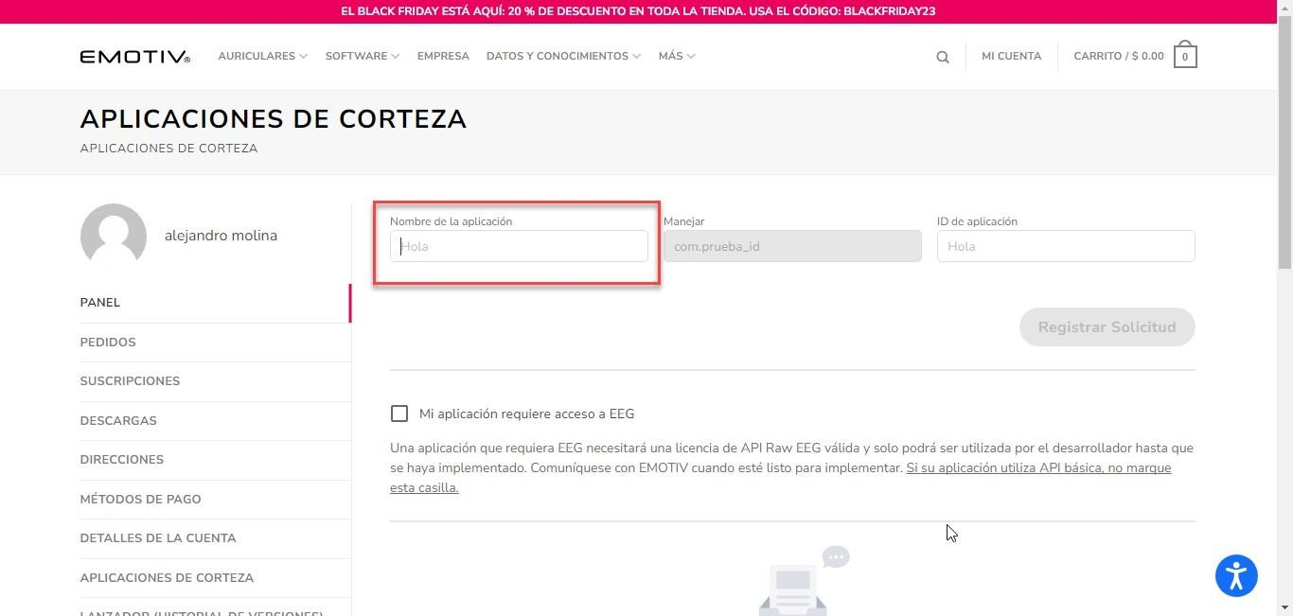

Assign a name; in this case, it will be named “Clave” in the “App Name” field, and click the “Register Application” button.

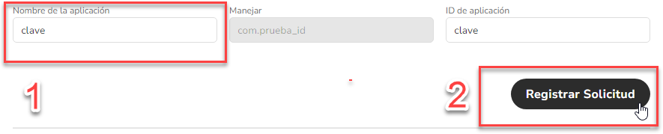

Figure 33 Application Registration

At the bottom of the platform, two keys (Client Secret and Client ID) will be generated. These keys allow the program to run and obtain data through the headset.

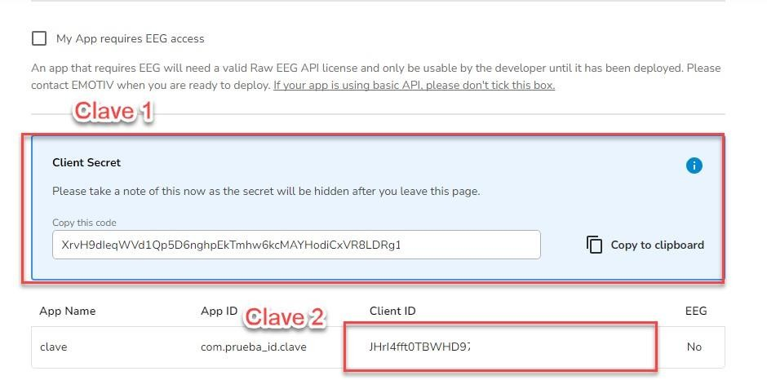

Figure 34 Key Generation

Note: The “Client Secret” key must be kept in a secure place, as it, along with the “Client ID” key, is necessary for the program's functionality. However, this key cannot be recovered if lost; otherwise, a new key must be generated.

The next step is to open the “Config.cs” file.

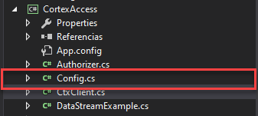

Figure 35 Config.cs

Within the code, there are two variables (AppClientId and AppClientSecret).

Image 49

Figure 36 Authentication Variables

In these two variables, enter the two keys obtained from the Cortex Apps platform. The Client ID key will be declared in the appClientId variable, and the Client Secret key will be declared in the appClientSecret variable.

### Example:



Figure 37 Variables for authentication

Once these modifications are made in the project’s source code, proceed to run

A time having are modifications made in it code fountain of the project, now we proceed to execute the program.

Before of execute he program, we will change the following configuration, in the top of the Image 50screen, we will change the next option.

Figure 38 EELogger Option

We select the option “ BandpowerLogger ”.

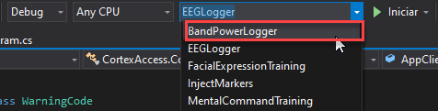

Figure 39 BandpowerLogger

And run the program.

Image 53

Figure 40 Program Execution

If running the program displays a window similar to Figure 20, it means that all steps were

completed correctly.

.

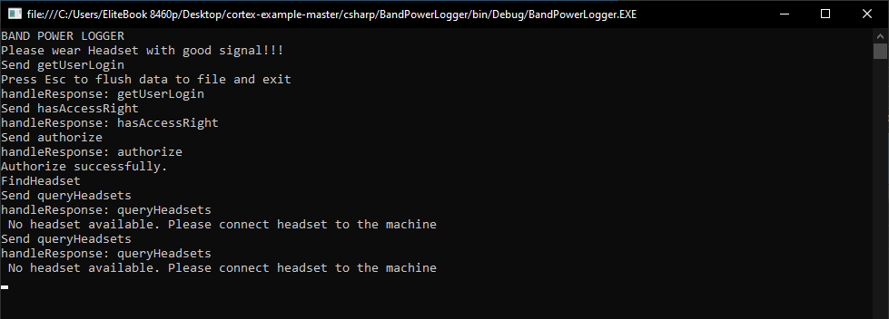

Figure 41Connection Authentication

In this case, the program will indicate that you need to connect the headset to the computer for data collection, which means the program is ready to use.

**NOTE:** It is necessary to have the “EMOTIV Launcher” program open and logged in for the program to function correctly; otherwise, it will not work.

When the program is running and the headset is connected, all data captured by the headset will be stored in an Excel file with a CSV extension named “BandPowerLogger”. To access the Excel file, go to the following directory within the program’s files:

#### Directory:

#### cortex-example-master > csharp > BandPowerLogger > bin > Debug

Figure 42 Generated Documents

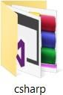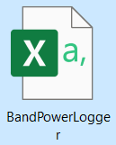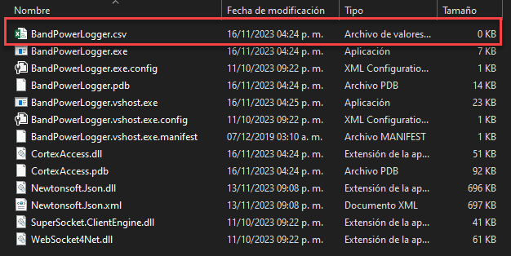

Figure 42 shows the files of the readings made by the headset while in use, displaying the time (TimeSpan) and the five electrodes of the headset (AF3, AF4, T7, T8, and PZ), each with its five types of waves (Theta, Alpha, Gamma, Beta low, and Beta high).

**Recording Movement of the Cube**

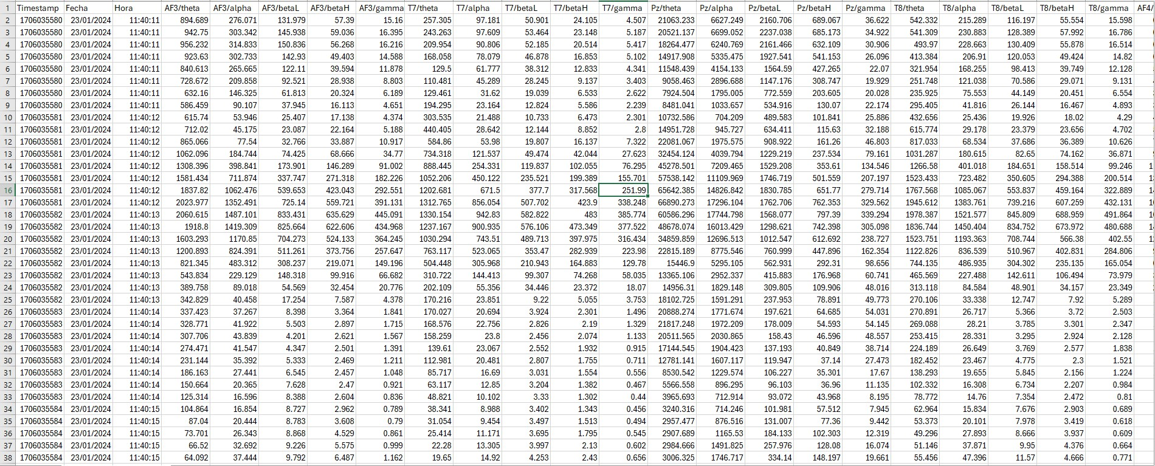

Figure 43 Datos iniciales

**First movement (Right)**

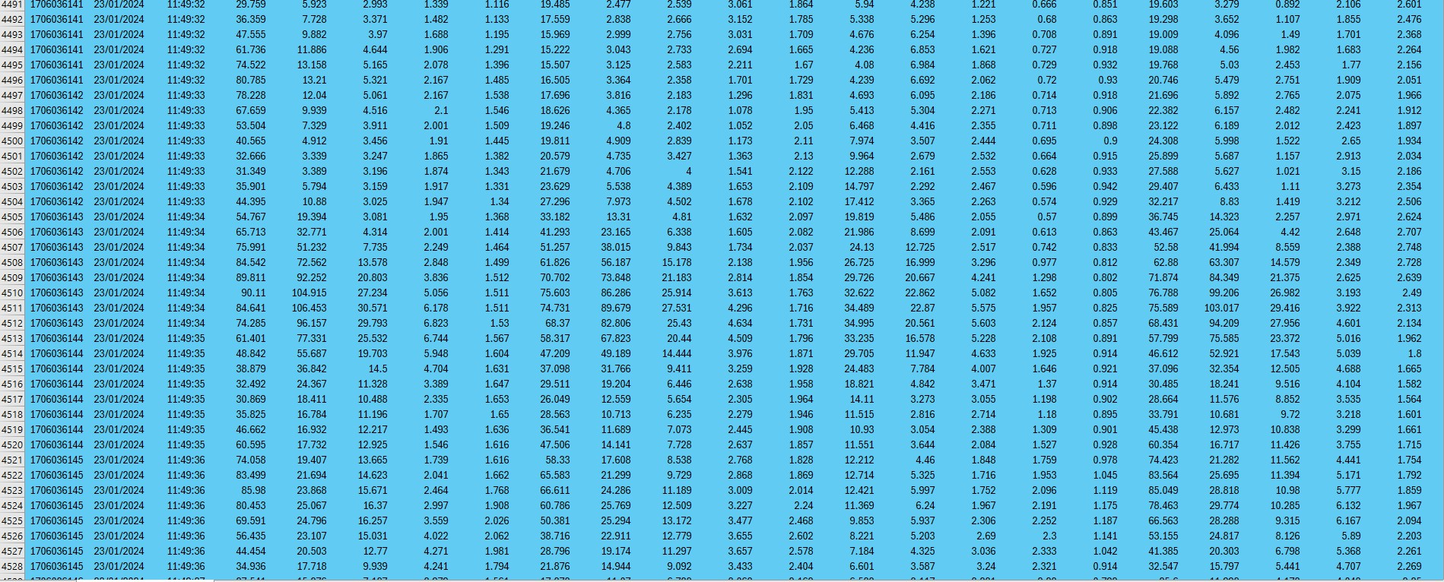

Figure 44 Right Side Motion Register

**Second movement (Lifted)**

Figure 45 Standing Motion Registration

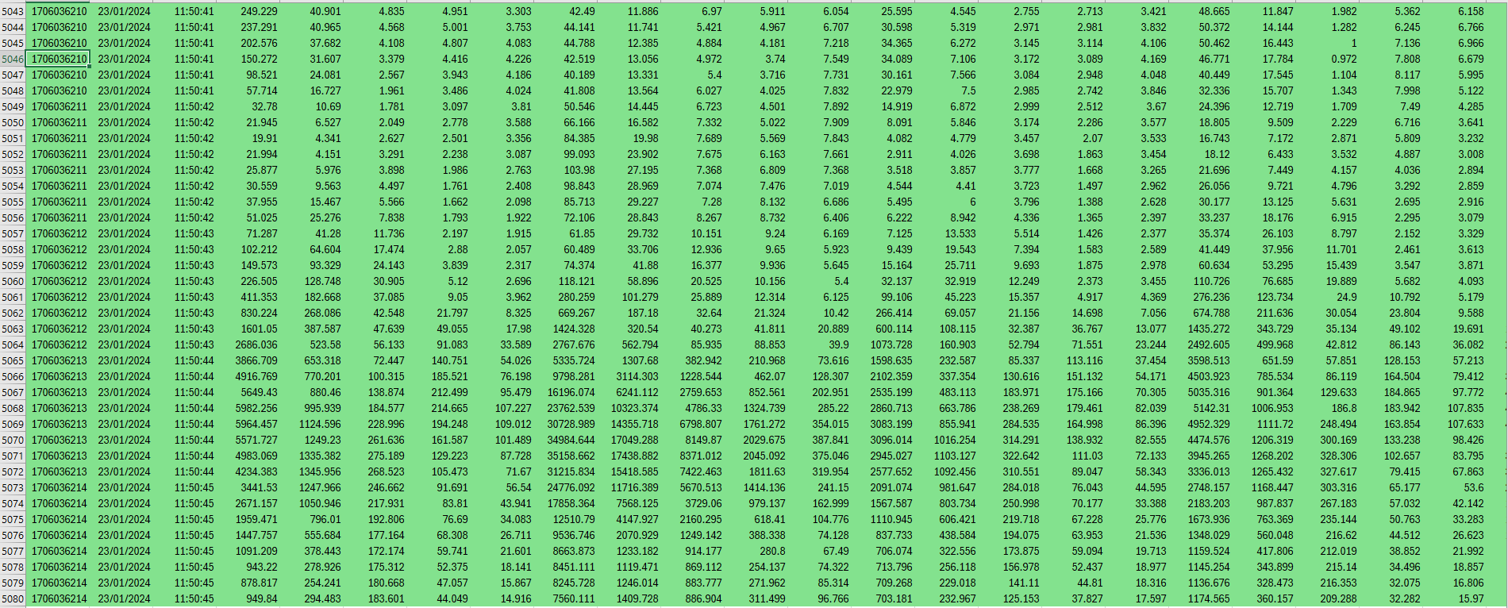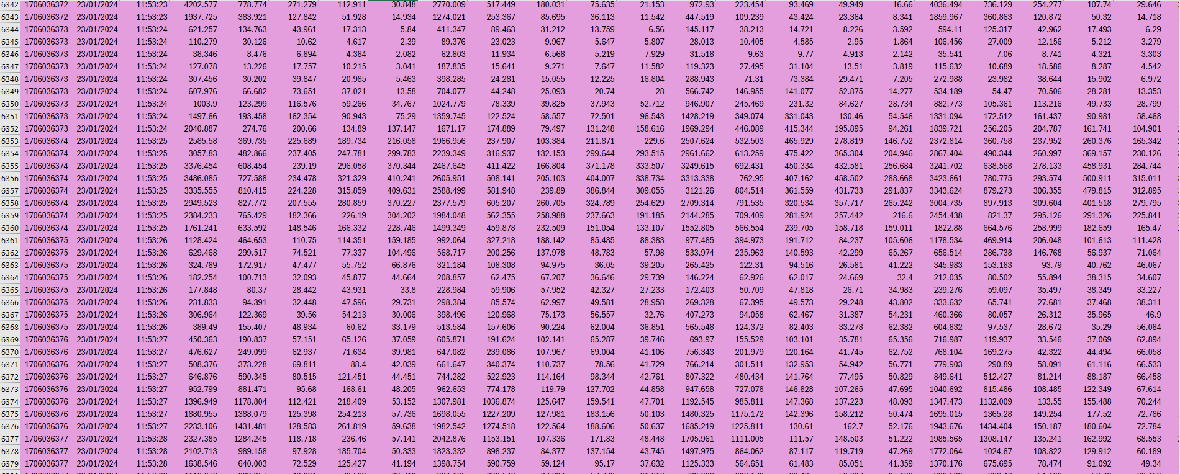

**Third movement (Left)**

Figure 46  Left side motion register

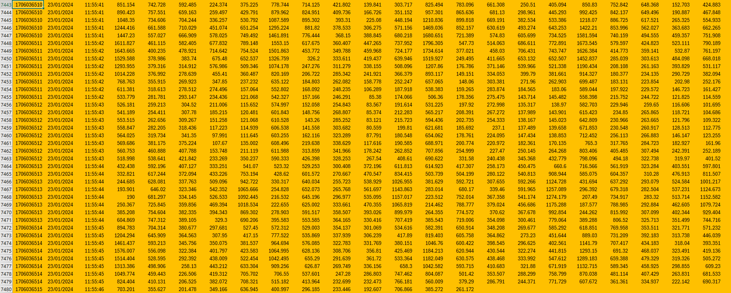

**Fourth movement (Push)**

Figure 47 Thrust Motion Log